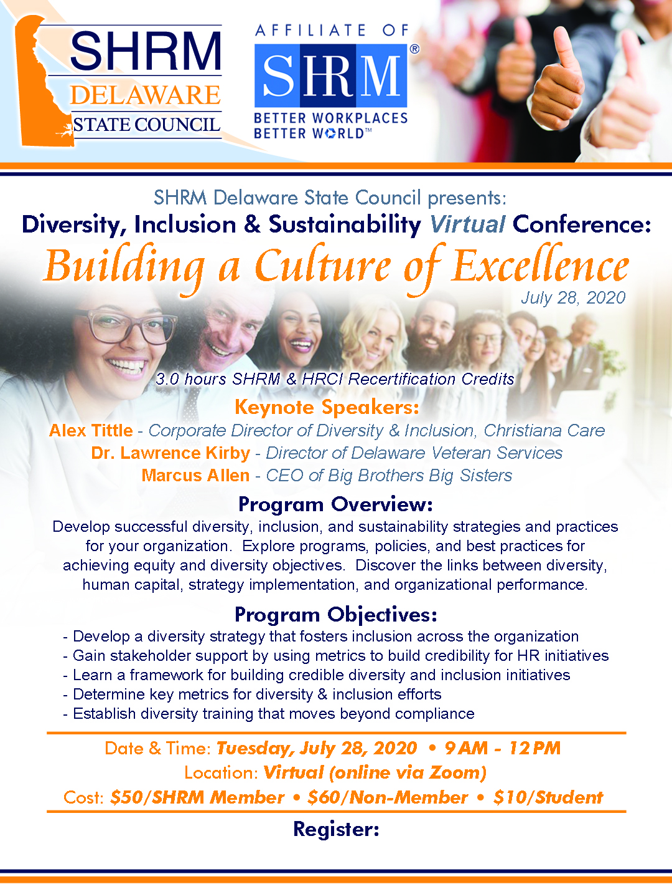

<http://delawaresc.shrm.org/events/2020/07/diversity-inclusion-sustainability-conference>